SIMULATION OF AN HPGe DETECTOR AND A MARINELLI’S BEAKER SOURCE TO DERIVE EFFICIENCY CURVES WITH FLUKA 2005.6

A.A. Porta, F. Campi

Nuclear Engineering department – CeSNEF, Polytechnic of Milan

Short informations

In this document you can find:
- a description of the work done with methods and results involving a Marinelli’s beaker certified calibration source as a multiline reference
- the layouts of .inp and source.f files used as FLUKA input and custom-source respectively
- the HPGe layout as computed by SimpleGeo beta version 1.0 (Chris Theis and Karl Heinz Buchegger)

Methods

FLUKA code was used in its lower-limit energy range with a custom source to simulate photons emission and transport from a Marinelli’s beaker multiline calibration source to an HPGe detector. This way it is possible to construct a topic total-efficiency curve without having a specific calibration reference.

The first step foresees to know as well as possible the inner geometry of the HPGe endcup. The task is quite simple if it possible to make a radiography or a gammagraphy of the device.
In figure 1 it is possible to see the result of a gammagraphy made with Cs-137 of such a detector.

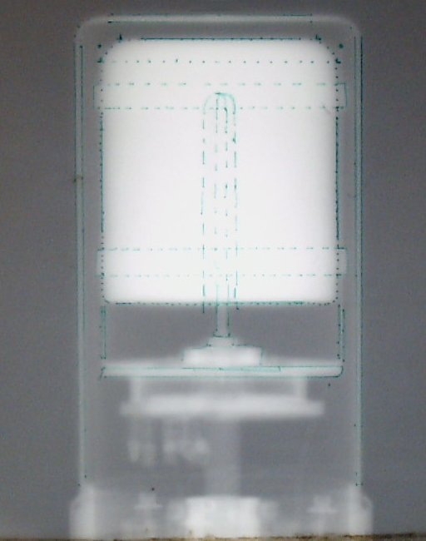
Figure 1: HPGe gammagraphy made by Cs-137

The information coming from the radiography or gammagraphy need to be blended with the data furnished by the device producer. The schemes furnished by producers are often poor in some structural detail. Typically, it is noticeable the absence of small internal clamps which, instead, are visible through a radiography or gammagraphy (see figure 1).

The second step deals with the proper simulation of the materials involved. In a Marinelli’s beaker must be defined, as accurately as possible, all the walls (typically made up of polypropylene or polystyrene) due to their thickness from 2 to 3 mm and, of course, the inner matrix. The matrix containing the radionuclides is well known both in density and in chemical composition in case of a calibration source being used. Almost always, in a typical situation, the matrix composition and density are more or less roughly known. As obvious, to overcome such a problems, it is necessary to setup several physical and chemical analysis to better understand the sample.
Materials existing only in trace, or constituting thin layers, can be neglected without altering, appreciably, the results. This is a great simplification in defining the matrix composition and it allows, also, to neglect thin layers inside HPGe endcup (i.e.: lithium or boron contact layers…). This simulation foresees only aluminum, germanium and vacuum to describe the HPGe detector.

The third step is to properly consider the dead layer (DL) of the HPGe crystal. It is fundamental to start the simulations from the nominal values declared by the producer. The dead layer definition is very important, in particular, in the medium-low energy range. About below 200 keV, small variations in DL give big variations in total efficiency simulations. However, the DL thicknesses give a further degree of freedom, in fact, enhancing the DL thickness it is possible to simulate an ageing of the crystal (i.e.: a general reduction in total efficiency). Moreover, adjusting DL offers the opportunity to overcome errors in determining the real thicknesses of the structures inside the endcup as they were estimated from the radiography or gammagraphy. The DL should be considered correct, in practice, if the simulated total efficiency lays within a proper range, such as ±10% or less.

The “source.f” file

Here it follows the source.f file for the specific case:

*$ CREATE SOURCE.FOR
*COPY SOURCE
*
*Elenco whats(x)
*Energia(MeV) - Zup - Zdown - Zrif - Rin - Rout // sdum: MAR
*Energia(MeV) - Zup - Zdown - R // sdum: CIL
*
*
*=== source Marinelli e Cilindrica ====================================*
*
SUBROUTINE SOURCE (NOMORE)

INCLUDE '(DBLPRC)'
INCLUDE '(DIMPAR)'
INCLUDE '(IOUNIT)'
*
*
INCLUDE '(BEAMCM)'
INCLUDE '(FHEAVY)'
INCLUDE '(FLKSTK)'
INCLUDE '(IOIOCM)'
INCLUDE '(LTCLCM)'
INCLUDE '(PAPROP)'
INCLUDE '(SOURCM)'
INCLUDE '(SUMCOU)'
*
LOGICAL LFIRST
DOUBLE PRECISION Vup
DOUBLE PRECISION Vdown
DOUBLE PRECISION MYTETA
DOUBLE PRECISION MYRHO
*
SAVE LFIRST
DATA LFIRST / .TRUE. /
*======================================================================*
* VERSION 1.0 *
*======================================================================*
NOMORE = 0
* +-------------------------------------------------------------------*
* | First call initializations:
IF ( LFIRST ) THEN
* | *** The following 3 cards are mandatory ***
TKESUM = ZERZER
LFIRST = .FALSE.
LUSSRC = .TRUE.
* | *** User initialization ***
END IF
* |
* +-------------------------------------------------------------------*
* Push one source particle to the stack. Note that you could as well
* push many but this way we reserve a maximum amount of space in the
* stack for the secondaries to be generated
* NPFLKA is the stack counter: of course any time source is called it
* must be =0
NPFLKA = NPFLKA + 1
* WTFLK is the weight of the particle
WTFLK (NPFLKA) = ONEONE
WEIPRI = WEIPRI + WTFLK (NPFLKA)
* Particle type (1=proton 7=photon). Is the type set by the BEAM
* card
ILOFLK (NPFLKA) = 7
* From this point .....
* Particle generation (1 for primaries)
LOFLK (NPFLKA) = 1
* User dependent flag:
LOUSE (NPFLKA) = 0
* User dependent spare variables:
DO 100 ISPR = 1, MKBMX1
SPAREK (ISPR,NPFLKA) = ZERZER
100 CONTINUE
* User dependent spare flags:
DO 200 ISPR = 1, MKBMX2
ISPARK (ISPR,NPFLKA) = 0
200 CONTINUE
* Save the track number of the stack particle:
ISPARK (MKBMX2,NPFLKA) = NPFLKA
NPARMA = NPARMA + 1
NUMPAR (NPFLKA) = NPARMA
NEVENT (NPFLKA) = 0
DFNEAR (NPFLKA) = +ZERZER
* ... to this point: don't change anything
* Particle age (s)
AGESTK (NPFLKA) = +ZERZER
AKNSHR (NPFLKA) = -TWOTWO
* Group number for "low" energy neutrons, set to 0 anyway
IGROUP (NPFLKA) = 0
* Kinetic energy of the particle (GeV)
TKEFLK (NPFLKA) = WHASOU(1)*1.D-3
* Particle momentum
PMOFLK (NPFLKA) = SQRT ( TKEFLK (NPFLKA)
& * ( TKEFLK (NPFLKA) + TWOTWO
& * (AM (ILOFLK (NPFLKA) ) )) )
* Cosines (TXFLK,TYFLK,TZFLK)
CALL RACO(TXX,TYY,TZZ)
TXFLK (NPFLKA) = TXX
TYFLK (NPFLKA) = TYY
TZFLK (NPFLKA) = TZZ
* Polarization cosines:
TXPOL (NPFLKA) = -TWOTWO
TYPOL (NPFLKA) = +ZERZER
TZPOL (NPFLKA) = +ZERZER
* Particle coordinates
*======================================================================*
* Caso Marinelli SDUSOU = MAR
IF (SDUSOU .EQ. 'MAR') THEN
Vup=(WHASOU(2)-WHASOU(4))*TWOPIP*(WHASOU(6)**2)
Vdown=(WHASOU(4)-WHASOU(3))*TWOPIP*(WHASOU(6)**2-WHASOU(5)**2)
*
IF (FLRNDM(V) .GE. (Vup/(Vup+Vdown))) THEN
* estrazione dalla ciambella
ZFLK (NPFLKA) = WHASOU(3)+(WHASOU(4)-WHASOU(3))
& *FLRNDM(ZFLK)
MYTETA = TWOPIP*FLRNDM(TETA)
MYRHO = SQRT(WHASOU(5)**2+(WHASOU(6)**2-WHASOU(5)**2)
& *FLRNDM(RHO))
ELSE
* estrazione dal cilindro
ZFLK (NPFLKA) = WHASOU(4)+(WHASOU(2)-WHASOU(4))
& *FLRNDM(ZFLK)
MYTETA = TWOPIP*FLRNDM(TETA)
MYRHO = WHASOU(6)*SQRT(FLRNDM(RHO))
ENDIF
XFLK (NPFLKA) = MYRHO*COS(MYTETA)
YFLK (NPFLKA) = MYRHO*SIN(MYTETA)
*======================================================================*
ELSE IF (SDUSOU .EQ. 'CIL') THEN
ZFLK (NPFLKA) = WHASOU(3)+(WHASOU(2)-WHASOU(3))
& *FLRNDM(ZFLK)
MYRHO = WHASOU(4)*SQRT(FLRNDM(RHO))
MYTETA = TWOPIP*FLRNDM(TETA)
XFLK (NPFLKA) = MYRHO*COS(MYTETA)
YFLK (NPFLKA) = MYRHO*SIN(MYTETA)
ELSE
ENDIF
*======================================================================*
* Calculate the total kinetic energy of the primaries: don't change
IF ( ILOFLK(NPFLKA) .NE. 0 ) THEN
TKESUM = TKESUM + ( TKEFLK (NPFLKA) + AMDISC (ILOFLK(NPFLKA)) )
& * WTFLK (NPFLKA)
ELSE
TKESUM = TKESUM + TKEFLK (NPFLKA) * WTFLK (NPFLKA)
END IF
* Here we ask for the region number of the hitting point.
* NRGFLK (NPFLKA) = ...
* The following line makes the starting region search much more
* robust if particles are starting very close to a boundary:
CALL GEOCRS ( TXFLK (NPFLKA), TYFLK (NPFLKA), TZFLK (NPFLKA) )
CALL GEOREG ( XFLK (NPFLKA), YFLK (NPFLKA), ZFLK (NPFLKA),
& NRGFLK (NPFLKA), IDISC )
* Do not change these cards:
CALL GEOHSM ( NHSPNT (NPFLKA), 1, -11, MLATTC )
NLATTC(NPFLKA) = MLATTC
CALL SOEVSV
RETURN
*=== End of subroutine Source =========================================*
END

The source is twofold, it can manage a Marinelli’s beaker and a cylinder source specifying “MAR” or “CIL” in the main “.inp” file. The event generator for the cylinder source is self explaining, whereas, in the case of Marinelli’s beaker it should be noticed the procedure that choose whether extracting from the upper portion of the beaker or in the lower one. The choice is made according to the proportion between the upper and lower decaying masses to obtain a proper probability distribution.
The source accept only one photon energy at each run.
The figure 2 displays a test to verify the proper events distribution inside a Marinelli’s beaker.
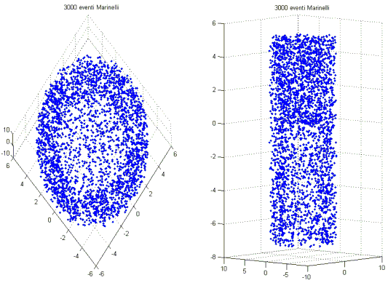
Figure 2: 3000 events distributed inside a Marinelli's beaker, as derived from the "source.f"

The “.inp” file

Here it follows the “.inp” file in its most general format and for an Am-241 photon emission:

TITLE
Analisi in efficienza rivelatore HPGe - lab. radioprotezione
*...+....1....+....2....+....3....+....4....+....5....+....6....+....7....+...
* ATTIVAZIONE RUN TOTALMENTE ANALOGICO
*GLOBAL 1000.0 -1.0 0.0 0.0 0.0 0.0
DEFAULTS PRECISIO
*
*
*inizio stesura: 30/05/2005
*ultima modifica: 30/06/2005
*
*NOTE: analisi gamma geometria MARINELLI
*NOTE: DeadLayer superiore di 1.5mm
*NOTE: DeadLayer esterno di 1.2mm circa
*NOTE: DeadLayer interno di 0.05mm circa
*============ GEOMETRIA INIZIO ============================================
GEOBEGIN COMBINAT
0 0 Detectors in HPGe
*
*asse Z in su - asse Y a destra - asse X entrante
*...+....1....+....2....+....3....+....4....+....5....+....6....+....7....+...
* piani // XY HPGe
XYP 1 0.0
XYP 2 0.3
XYP 3 0.9
XYP 4 1.2
XYP 5 2.0
XYP 6 2.7
XYP 7 3.4
XYP 8 6.9
XYP 9 7.5
XYP 10 8.1
XYP 11 8.6
XYP 12 8.75
XYP 13 9.15
XYP 14 9.3
* cilindri HPGe
ZCC 15 0.0 0.0 0.15
ZCC 16 0.0 0.0 0.805
ZCC 17 0.0 0.0 1.0
ZCC 18 0.0 0.0 2.85
ZCC 19 0.0 0.0 2.95
ZCC 20 0.0 0.0 3.05
ZCC 21 0.0 0.0 3.45
ZCC 22 0.0 0.0 3.6
* sfera HPGe
SPH 23 0.0 0.0 6.9 0.805
* tronco di cono HPGe
TRC 24 0.0 0.0 8.1 0.0 0.0 0.5
2.85 2.5
* piani // XY Marinelli
*...+....1....+....2....+....3....+....4....+....5....+....6....+....7....+...
XYP 25 1.8
XYP 26 2.05
XYP 27 9.3
XYP 28 9.55
XYP 29 16.60
XYP 30 16.65
XYP 31 16.9
* cilindri Marinelli
*...+....1....+....2....+....3....+....4....+....5....+....6....+....7....+...
ZCC 32 0.0 0.0 3.6
ZCC 33 0.0 0.0 3.85
ZCC 34 0.0 0.0 5.70
ZCC 35 0.0 0.0 5.95
* cilindro e piani del limite geometria
RPP 36 -999999. 999999. -999999. 999999. -999999. 999999.
* cilindro deadlayer esterno 1mm per lato
*...+....1....+....2....+....3....+....4....+....5....+....6....+....7....+...
ZCC 37 0.0 0.0 2.73
TRC 38 0.0 0.0 8.1 0.0 0.0 0.35
2.70 2.35
* deadlayer interno
SPH 39 0.0 0.0 6.9 0.8
ZCC 40 0.0 0.0 0.8
*
END
*
*============ DEFINIZIONE DELLE REGIONI ==================================
* SINTASSI 2X A3 I5 9(A2 I5)
*.000.....--.....--.....--.....--.....--.....--.....--.....--.....--.....
* buco nero esterno
001 OR +36 +31 -1 -35
002 OR +36 -31
003 OR +36 +1
* aria tra Marinelli e HPGe
004 OR +14 -1 -22 +32
* aria sotto Marinelli
005 OR +25 -1 -32 +35
* tappo Marinelli (POLISTIRENE)
006 OR +34 +31 -30
* fondo basso marinelli (PS)
007 OR +26 -25 +34 -33
* pareti esterne Marinelli (PS)
008 OR +31 -25 +35 -34
* pareti interne Marinelli (PS)
009 OR +28 -25 +33 -32
* fondo alto Marinelli (PS)
010 OR +28 -27 +32
*.000.....--.....--.....--.....--.....--.....--.....--.....--.....--.....
*============== interno del Marinelli =====================
* zona superiore vuota
011 OR +30 -29 +34
* >>>> volume di 1L del Marinelli <<<<
012 OR +29 -28 +34 OR +28 -26 +34 -33
*==========================================================
*==================== HPGe ================================
* HPGe
013 OR +38 OR +8 -5 +37 -16 OR +10 -8 +37 -23
*==========================================================
*.000.....--.....--.....--.....--.....--.....--.....--.....--.....--.....
* alluminio della capsula esterna protettiva HPGe (laterale)
014 OR +14 -1 +22 -21
* alluminio della capsula esterna protettiva HPGe (superiore)
015 OR +14 -13 +21
* alluminio della capsula interna protettiva HPGe (laterale)
016 OR +12 -1 +19 -18
* alluminio della capsula interna protettiva HPGe (superiore)
017 OR +12 -11 +18
* fascia superiore HPGe (alluminio)
018 OR +9 -8 +20 -19
* fascia inferiore HPGe (alluminio)
019 OR +7 -6 +20 -19
* stelo conduttore interno HPGe (alluminio)
020 OR +8 -4 +15
* base piccola sotto lo stelo (alluminio)
021 OR +4 -3 +40
* base media sotto lo stelo (alluminio)
022 OR +3 -2 +17
* base grande sotto lo stelo (alluminio)
023 OR +2 -1 +18
*.000.....--.....--.....--.....--.....--.....--.....--.....--.....--.....
* vuoto tra i rivestmenti parte alta
024 OR +13 -12 +19
* vuoto parte laterale sopra fascia superiore
025 OR +13 -9 +21 -19
* vuoto parte laterale accanto fascia superiore
026 OR +9 -8 +21 -20
* vuoto parte laterale tra le due fasce
027 OR +8 -7 +21 -19
* vuoto parte laterale accanto fascia inferiore
028 OR +7 -6 +21 -20
* vuoto parte laterale sotto fascia inferiore
029 OR +6 -1 +21 -19
* vuoto dentro sfera
030 OR +39 -8
* vuoto attorno stelo
031 OR +8 -4 +40 -15
* vuoto attorno stelo sopra base media
032 OR +5 -3 +18 -40
* vuoto attorno base meia sopra base grande
033 OR +3 -2 +18 -17
* vuoto attrono tronco cono HPGe
034 OR +11 -10 +18 -24
*.000.....--.....--.....--.....--.....--.....--.....--.....--.....--.....
* dead layer esterno
035 OR -38 +24
036 OR +18 -37 +10 -5
* dead layer interno
037 OR +23 -39 -8
038 OR +8 -5 +16 -40
*
END
GEOEND
*
*============ DEBUG DELLA GEOMETRIA ================================
*...+....1....+....2....+....3....+....4....+....5....+....6....+....7....+...
*GEOEND 30.0 30.0 30.0 -5.5 -5.5 -5.5DEBUG
*GEOEND 300.0 300.0 300.0 &
*STOP
*
*GEOEND 10.0 10.0 10.0 0.0 0.0 0.0DEBUG
*GEOEND 100.0 100.0 100.0 &
*STOP
*
*============ MATERIALI ============================================
*...+....1....+....2....+....3....+....4....+....5....+....6....+....7....+...
*MATERIAL 0.0 0.0 0.0 2.0 VACUUM
*MATERIAL 1.0 1.0079 0.000089 3.0 HYDROGEN
*MATERIAL 6.0 12.011 2.0 6.0 CARBON
*MATERIAL 7.0 14.0067 0.0012506 7.0 NITROGEN
*MATERIAL 8.0 15.9994 0.001429 8.0 OXYGEN
*MATERIAL 12.0 24.305 1.738 9.0 MAGNESIU
*MATERIAL 13.0 26.982 2.6989 10.0 ALUMINUM
*MATERIAL 26.0 55.847 7.874 11.0 IRON
*
MATERIAL 18.0 39.948 0.001784 26.0 0.0 0.0ARGON
MATERIAL 32.0 72.16 5.33 27.0 0.0 0.0GERMANIU
MATERIAL 0.0 0.0 0.001225 28.0 0.0 0.0AIR
MATERIAL 0.0 0.0 1.06 29.0 0.0 0.0POLIST
MATERIAL 0.0 0.0 1.394 30.0 0.0 0.0MYLAR
MATERIAL 0.0 0.0 1.0 31.0 0.0 0.0H2O
MATERIAL 0.0 0.0 0.9 32.0 0.0 0.0POLIPR
MATERIAL 0.0 0.0 1.032 33.0 0.0 0.0EPOXY
*
* definizione composti
COMPOUND -0.78 -7.0 -0.21 -8.0 -0.01 -26.0AIR
COMPOUND 8.0 3.0 8.0 6.0 POLIST
COMPOUND 8.0 3.0 3.0 6.0 POLIPR
COMPOUND 19.0 3.0 18.0 6.0 3.0 8.0EPOXY
COMPOUND 8.0 3.0 10.0 6.0 4.0 8.0MYLAR
COMPOUND 2.0 3.0 1.0 8.0 H2O
*
*============ ASSEGNAZIONE DEI MATERIALI ALLE REGIONI ===============
* materiale -> regione
*...+....1....+....2....+....3....+....4....+....5....+....6....+....7....+...
ASSIGNMA 1. 1. 3.
ASSIGNMA 28. 4. 5.
ASSIGNMA 29. 6. 10.
*============ materiale Nel Marinelli ==============
* aria sopra pelo libero
ASSIGNMA 28. 11.
* materiale di riempimento
ASSIGNMA 33. 12.
*===================================================
*================== HPGe =========================
ASSIGNMA 27. 13.
*===================================================
ASSIGNMA 10. 14. 23.
ASSIGNMA 2. 24. 34.
*=========== HPGe deadlayer esterno ================
ASSIGNMA 27. 35. 36.
*=========== HPGe deadlayer interno ================
ASSIGNMA 27. 37. 38.
*
*============ DEFINIZIONE DELLA SORGENTE GAMMA ======================
* elenco whats(x):
* Energia(MeV) - Zup - Zdown - Zrif - Rin - Rout // sdum: MAR
* Energia(MeV) - Zup - Zdown - R // sdum: CIL
*...+....1....+....2....+....3....+....4....+....5....+....6....+....7....+...
* americio riga a 59.54 keV
SOURCE 0.05954 14.55 2.05 9.55 3.85 5.7MAR
*============ EMF E SOGLIE ==========================================
*...+....1....+....2....+....3....+....4....+....5....+....6....+....7....+...
EMF
EMFCUT 512.E-6 1.E-6 0.0 2.0 33.0 1.0PROD-CUT
*
EVENTYPE EVAP
PHYSICS 2.0 EVAPORAT
*
*============ REGISTRAZIONE DEGLI EVENTI ==============================
*...+....1....+....2....+....3....+....4....+....5....+....6....+....7....+...
* rilevamento da 0 1024 keV
DETECT 0.0 0.0 1.024E-3 0.0 13.0HPGE
* rilevamento da 1000 keV a 2024 keV
*DETECT 0.0 1.E-3 2.024E-3 0.0 13.0HPGE
*====================================================================
*...+....1....+....2....+....3....+....4....+....5....+....6....+....7....+...
RANDOMIZE 1.
*
*start
*
START 2.E+7 99999999. 99999000.
STOP

A typical result, “plotting a DETECT card”, can be seen in figure 3 for a Cs-137 gamma:
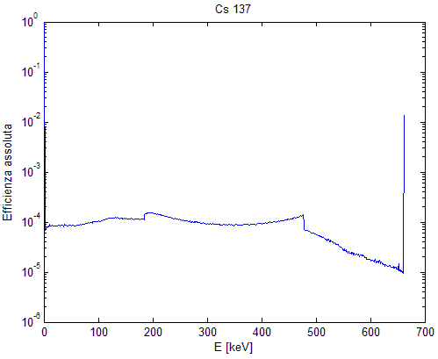
Figure 3: Cs-137 spectrum as simulated by FLUKA

The spectra displayed in figure 3 derives from simulating a Marinelli’s source with 661.6 keV photons from Cs-137. The matrix was made by epoxy resin with density of 1.0 g/cm^3.
The Dls were set to 1.5mm for the front-end of the device and to 1.2mm for the external surface.
The results of the performed simulations are displayed in figure 4:
Figure 4: experimental and simulated total efficiencies

The captions “SILENA” and “1,5+1,2+0,05mm” in figure 4 represents the experimental values and the simulated ones. The differences between experimental and simulated values lies in the range ±10% as shown in table 1.

Table 1: comparison between experimental and simulated efficiencies
E [keV] | Nuclide | Experimental values |  | DLs: 1.5 + 1.2 + 0.05 mm – FLUKA simulations
E [keV] | Nuclide | efficiency | uncertainty | efficiency | uncertainty | Difference %
59,54 | Am-241 | 0,0071 | 0,0003 | 0,0072 | 0,0009 | 1,18%
88,03 | Cd-109 | 0,0259 | 0,0009 | 0,0245 | 0,001 | -5,23%
122,06 | Co-57 | 0,0363 | 0,0012 | 0,0351 | 0,0006 | -3,40%
159,00 | Te-123m | 0,0377 | 0,0012 | 0,0371 | 0,0007 | -1,64%
320,08 | Cr-51 | 0,0244 | 0,0007 | 0,0250 | 0,0007 | 2,62%
391,69 | Sn-113 | 0,0227 | 0,0007 | 0,0213 | 0,0007 | -6,13%
514,01 | Sr-85 | 0,0180 | 0,0005 | 0,0171 | 0,0007 | -5,14%
661,66 | Cs-137 | 0,0155 | 0,0005 | 0,0141 | 0,0011 | -9,15%
898,04 | Y-88 | 0,0113 | 0,0003 | 0,0113 | 0,0015 | 0,15%
1173,24 | Co-60 | 0,0093 | 0,0003 | 0,0093 | 0,0007 | 0,02%
1332,50 | Co-60 | 0,0083 | 0,0003 | 0,0084 | 0,0037 | 1,00%
1836,06 | Y-88 | 0,0065 | 0,0002 | 0,0065 | 0,0063 | 0,15%

Another check was performed with a thin disc source of Eu-152. The results shown in table 2, again, confirm the goodness of the simulation within ±10%:

Table 2: Eu-152 disc source
γ emission | Absolute efficiency evaluation for an Eu-152 disc source reference
E [keV] | Experimental | DLs at 1.5+1.2+0.05 mm | Difference %
121.78 | 0.1419±0.0004 | 0.1511±0.0001 | +6.5%
344.28 | 0.0854±0.0003 | 0.0849±0.0003 | -0.6%

Conclusions

Tables 1 and 2 confirm the possibility to simulate an HPGe detector with FLUKA code. As obvious, the accurate knowledge of geometries and materials is crucial to obtain results with high accuracy. The principal difficulty is to determine the composition of the sample matrix. Anyway, accuracy within ±10-20% can be obtained without excessive troubles.

Further examples

ACTIVE CARBONS
The cylinder source (SDUM= CIL) undergoes further tests. The first test dealt with “active carbons” in the form of tiny powder. A polystyrene 100cc cylinder was filled with 42.262 g of active carbon and was measured for 72 h. After background subtraction, there were determined the CPS, as fitted by the acquisition software, of Ra-226 and Th-232. More precisely, there were analyzed 3 peaks for each nuclide as follows:

Chain | Energy | Nuclide
 | keV
Ra-226 | 352 | Pb-214
Th-232 | 583 | Tl-208
Ra-226 | 609 | Bi-214
Th-232 | 911 | Ac-228
Ra-226 | 1120 | Bi-214
Th-232 | 2614 | Tl-208

The cylinder source was filled in FLUKA with pure carbon at a density of 0.448 g/cm^3 and were performed 5 runs with 1*10^7 – 1*10^8 photons/run for each energy to collect the photopeak efficiency. Computing properly the branches, it was possible to collect the following values:

Ra-226 | 68 ± 10 Bq/kg
Th-232 | 33 ± 7 Bq/kg

The same sample was analyzed by another independent laboratory with different techniques and it was found that, again, the values were:

Ra-226 | 68 ± 6 Bq/kg
Th-232 | 35 ± 5 Bq/kg

The FLUKA simulation both of the HPGe and, above all, of the sample matrix were quite good.

SimpleGeo (beta version 1.0) layout of detector interiors

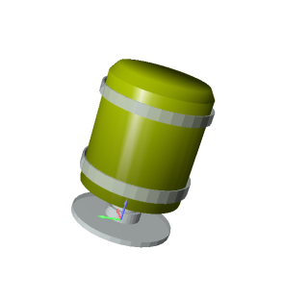 | 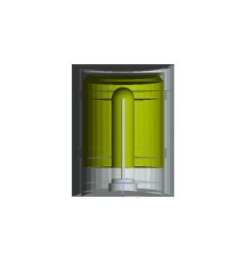
Gouraud Shading view | ZX-plane clip view
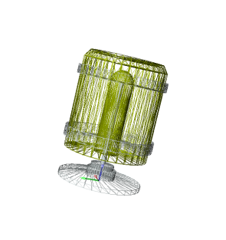 | 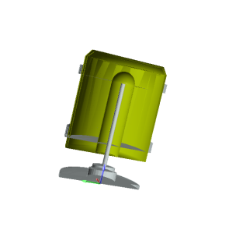
Wireframe view | Clip view

Alessandro.porta@polimi.it

