Irradiation geometry: 1.4 GeV proton beam hitting on big iron cylinder. Backscattered protons scored in dedicated fluence detector.

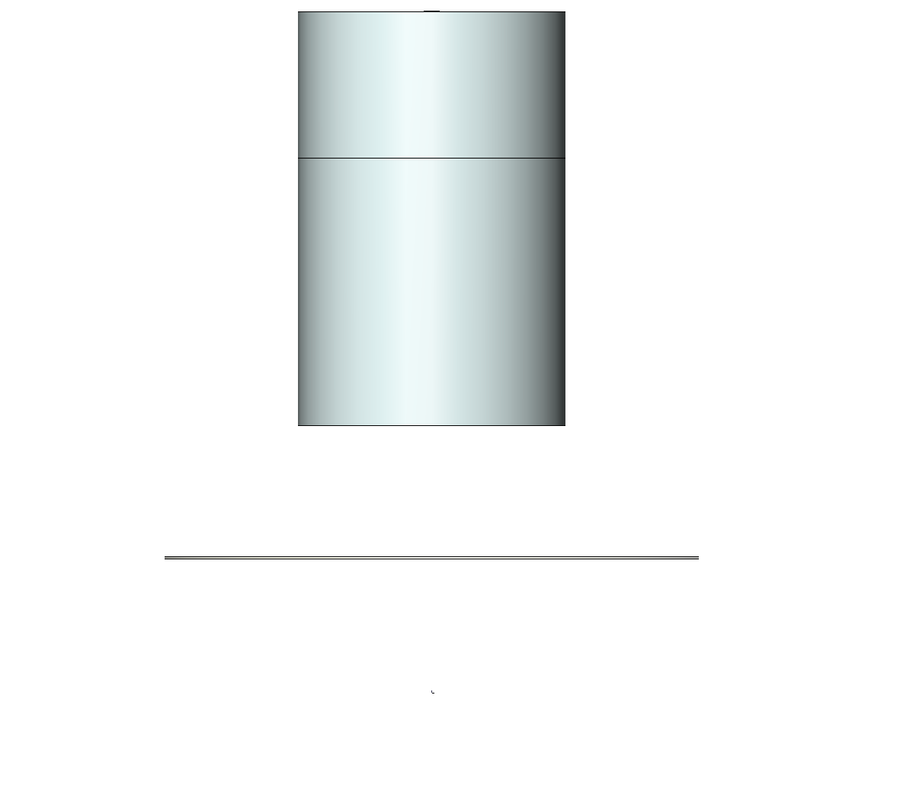

Proton beam with 1400 MeV

Iron cylinder, r= 50 cm , l= 1.55m

Proton fluence detector

Proton fluence (Ebin width multiplied with d/dE to show the total number of protons backscattered in each energy bin of 100MeV) seen in backward scattering detector



Although the statistics of this **analogue run** is not too good it clearly shows the tendency that we have more backscattering protons close to the initial proton energy than at lower energies. I have observed this tendency already at a second similar setup with better statistics. Any comments to this fluence shape are highly welcome.

**SimpleGeo+Pipsicad picture to analyse the physics of the observed high energy backscattering proton event:** These two tracks were extracted form 3E6 protons started.

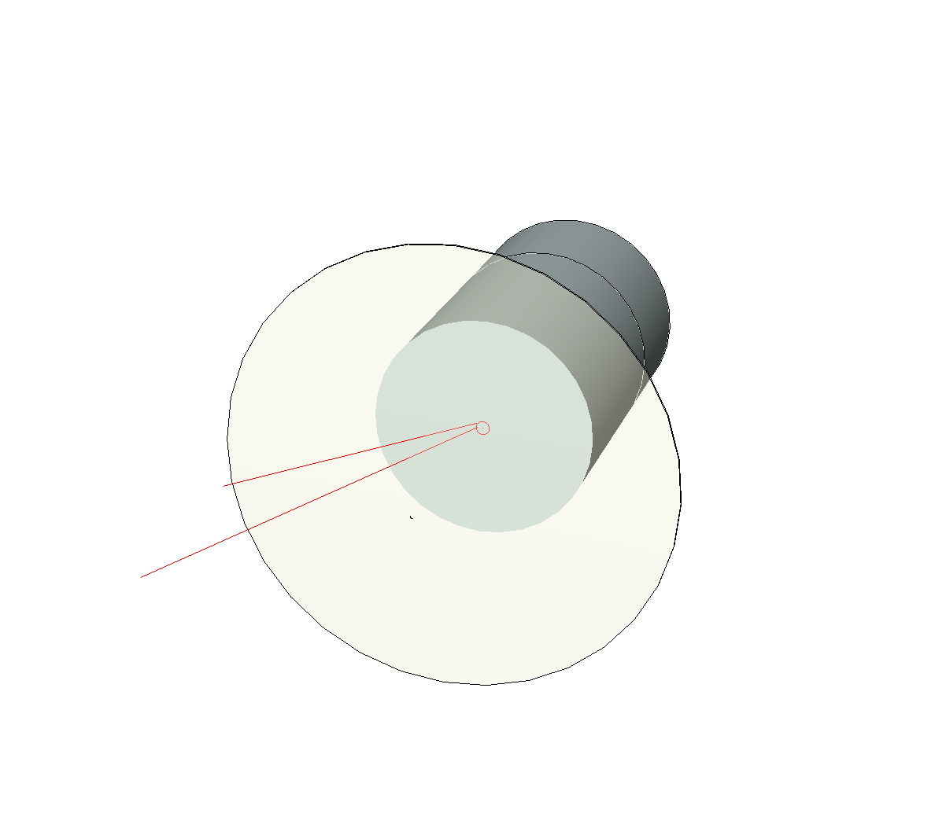

Zoom to inner part (r=3cm) of the iron cylinder, which is set transparent to see the proton tracks.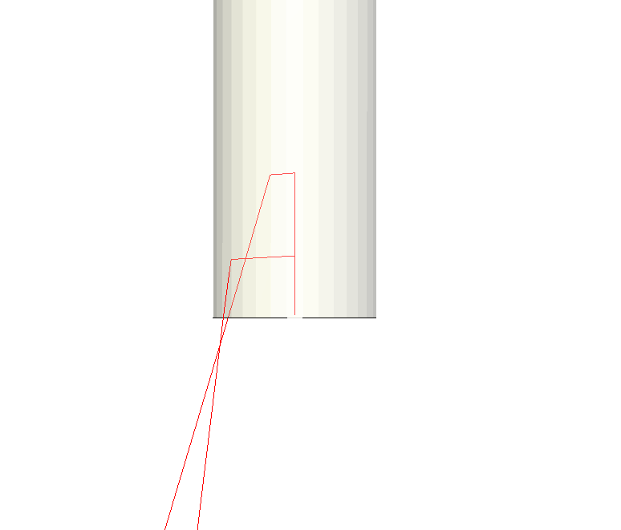

Incoming primary proton with 1400 MeV

13000 – 1350 MeV

1250 – 1300 MeV

Analysing the USERDUMP file, the backscattering events turned out to be double (elastic) scattering events, explaining the large angle of the scattered protons.

However, the shape of the fluence curve is still a bit mysterious to me. I expected a continuous fluence decrease with increasing energy. Opinions or even hard facts would be highly appreciated.