I have prepared a block of Silicon，then defined a hole filled with 6LiF.
Iin my understanding , Due to n+6Li→α+T，the process should be
- neutron come into 6LiF
- neutron react with 6Li
- α and T appear in LiF
- α and T lost energy in LiF while moving to the boundary of silicon region and LiF region
- α and T move across the boundary
- α and T lost energy in silicon and stop

I would like to calculate the following amount :
- energy deposition in both LiF region and Silicon region.
By setting USRBIN card , it is possible to calculate energy deposition in the wanted region and is it possible to integral all these density together and get the total energy deposition ？what should I do or where may I find the result ?

- the spectra of α partical both ①when the reaction takes place , and ②when they move across the intersurface of Lif region and silicon region.
Are the energy of all α particals be 2.05MeV when they are produced or there is a spactra to discribe the energy?
For ② USRBDX is adopted , and it works ,
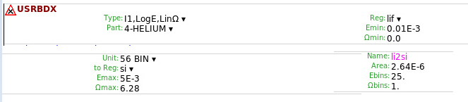
But I wander if USRBIN card may either deal with ② by setting Type(what1)：Region , R1from(what7) LiF ,R1to(what4) silicon ? One more question is , what does the parameter step1(what10) mean?
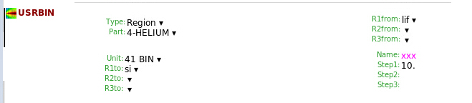

but for ① ， what should I do ? may I use USRTRACK card?
What does it mean by setting USRTRACK card to a special region ?
For example , in my work , I define a USRTRACK card ,set Reg(what4):LiF Part(2):4-Helium , does it work to obtain ① ?
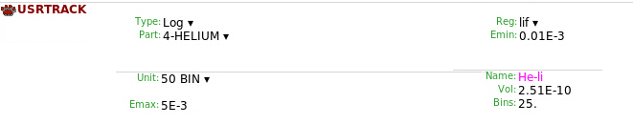
One more question , what’s the difference between USRCOLL and USRTRACK ? By reading those course pdf’s, I learned that USRTRACK cares about the total amount while USRCOLL have something to do with time(or amount in per unit time) . So , does USRCOLL make on sense in my case ? In what case should I use a USRCOLL card ?
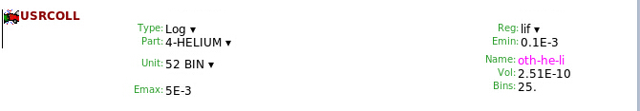
In fact , I can plot only with the output of my USRTRACK card , but not with the output of a USRCOLL card `, althought the inputs in these card are the same.

3.Normalizaton：for a point source ,most output is normalized to per
incident primary ,but what if set the source as a plane one ? just divide the output by the source area , or something else?

THANK YOU FOR YOUR ATTENTION~

