Proton scattering: Cosmic rays collide with galactic gas (gaseous hydrogen)
10TeV
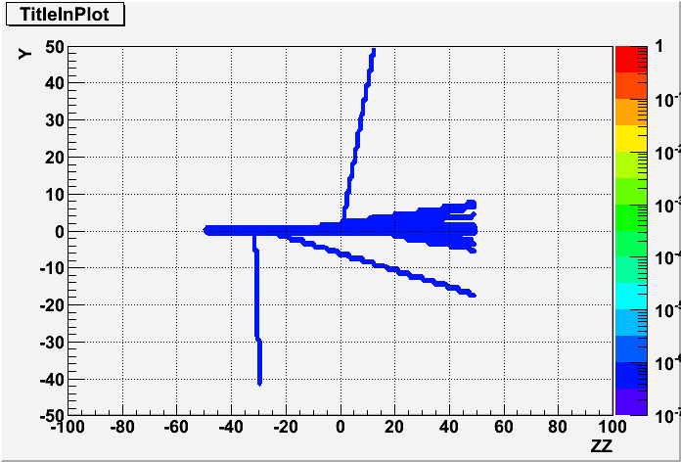

1TeV
